Problem statement formation

**Can Alzheimer be predicted?**

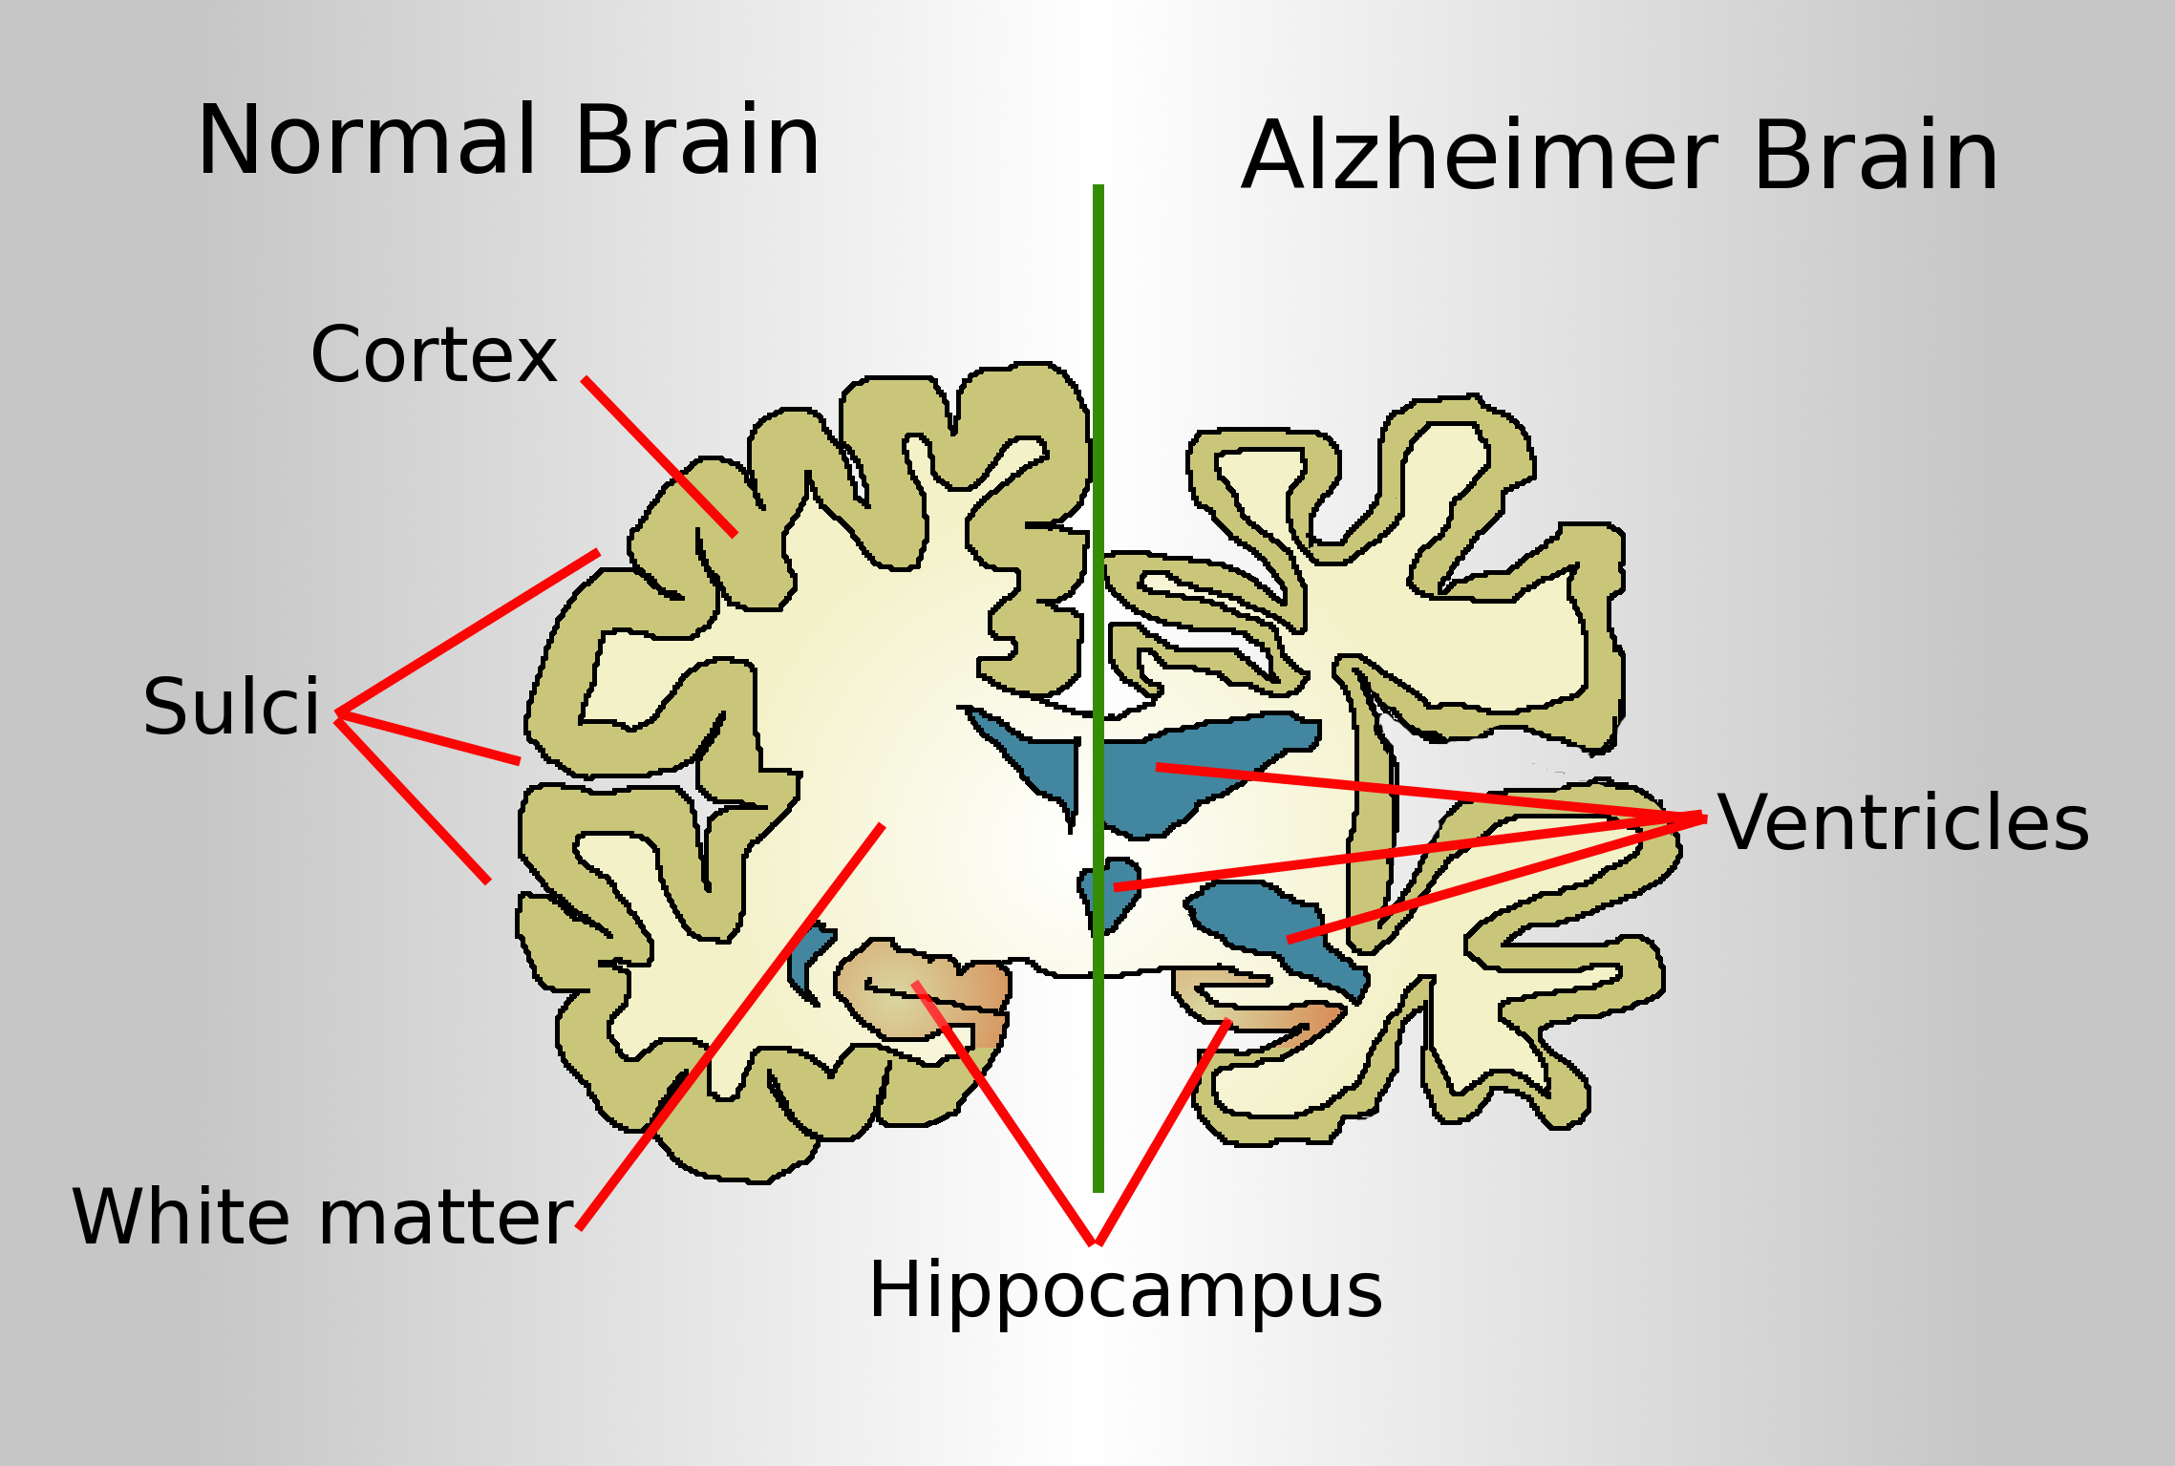

https://en.wikipedia.org/wiki/Alzheimer%27s_disease

**Context**

Alzheimer’s is the most common cause of Dementia to such an extent that it interferes with a person’s daily life and activities. Dementia is the loss of thinking, remembering, and reasoning and behavioral abilities. The aim of this is to detect and quantifying the severity of dementia by exploring the interactions between the features in Alzheimer subjects.

**Criteria for success**

Dementia can occur to people at any age and its possibility increase with age. In other word, Dementia does not happen to people because of aging. Tendency to Dementia does not related to gender or Social economy status, but education can be a factor in preventing Dementia. The severity of Dementia can be depended to the cognitive functionality of people. There is a correlation between the size of the brain volume and different part of brain and severity of Dementia.

**Scope of solution space**

The data from OASIS project will be used for this study which include two sets of data:

**Cross-sectional MRI Data in Young, Middle Aged, Nondemented and Demented Older Adults**: This set consists of a cross-sectional collection of 416 subjects aged 18 to 96. For each subject, 3 or 4 individual T1-weighted MRI scans obtained in single scan sessions are included. The subjects are all right-handed and include both men and women. 100 of the included subjects over the age of 60 have been clinically diagnosed with very mild to moderate Alzheimer’s disease (AD). Additionally, a reliability data set is included containing 20 nondemented subjects imaged on a subsequent visit within 90 days of their initial session.

**Longitudinal MRI Data in Nondemented and Demented Older Adults**: This set consists of a longitudinal collection of 150 subjects aged 60 to 96. Each subject was scanned on two or more visits, separated by at least one year for a total of 373 imaging sessions. For each subject, 3 or 4 individual T1-weighted MRI scans obtained in single scan sessions are included. The subjects are all right-handed and include both men and women. 72 of the subjects were characterized as nondemented throughout the study. 64 of the included subjects were characterized as demented at the time of their initial visits and remained so for subsequent scans, including 51 individuals with mild to moderate Alzheimer’s disease. Another 14 subjects were characterized as nondemented at the time of their initial visit and were subsequently characterized as demented a later visit.

Staging patients diagnosed with dementia is determined by a global rating scale, called clinical dementia rating scale (CDR). The CDR evaluates cognitive, behavioral, and functional aspects of Alzheimer disease and other dementias. Features used for applying machine learning from these two sets of data include age, education, gender, socioeconomic status (SES), Mini-Mental State Exam (MMSE) which is a test of cognitive function, eTIV - estimated Total Intracranial Volume (sum of brain, ventricular, and extraventricular CSF) and brain volumes (nWBV), and Atlas Scaling Factor (ASF) which is volume-scaling factor required to match each individual to the atlas target.

A supervised learning model will be used to capture the complex feature interactions in the sample of data and detecting and scoring AD from data.

**Constraints**

Theproposed model works for quantifying AD only from numeric input values. Therefore, the MRI image-based methods need to be pre-processed and useful information extracted in the form of numeric values and used as input to our proposed model for better results.

**Stakeholders**

This MRI data sets has been taken from Open Access Series of Imaging Studies (OASIS) which is a project aimed at making MRI data sets of the brain freely available to the scientific community. OASIS is made available by the Washington University Alzheimer’s Disease Research Center, Dr. Randy Buckner at the Howard Hughes Medical Institute (HHMI)( at Harvard University, the Neuroinformatics Research Group (NRG) at Washington University School of Medicine, and the Biomedical Informatics Research Network (BIRN).  
The outcome of the work can be used in basic and clinical neuroscience and as a supplement for clinical dementia rating